Directions to sign-up for a quiz star account where you will take your quizzes and tests.
Step 1: Go to http://quizstar.4teachers.org/ and click on the “Student Login Link”
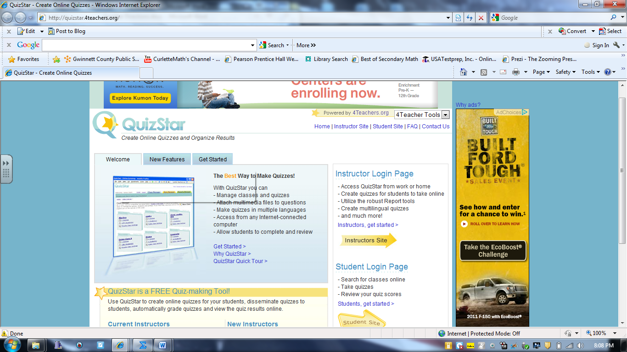

Step 2: Clink on the “Sign Up” arrow.
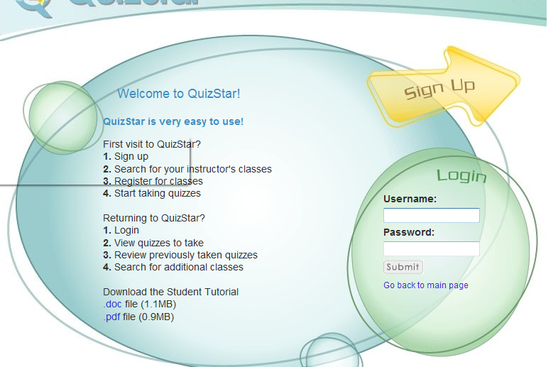

Step 3: Fill out the form and then click “Register”
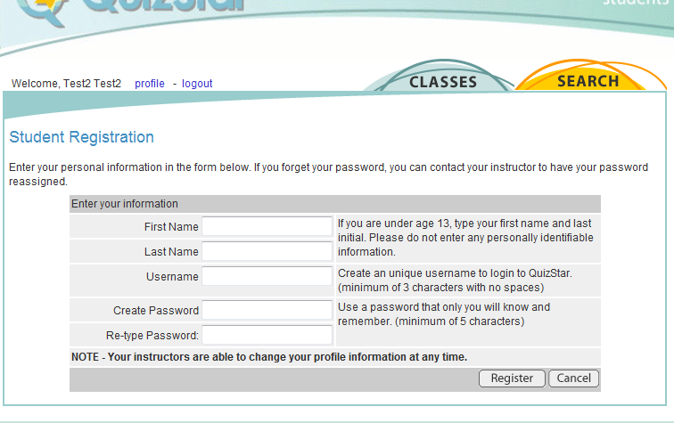

Step 4: Click on the Highlighted Yellow “SEARCH” button
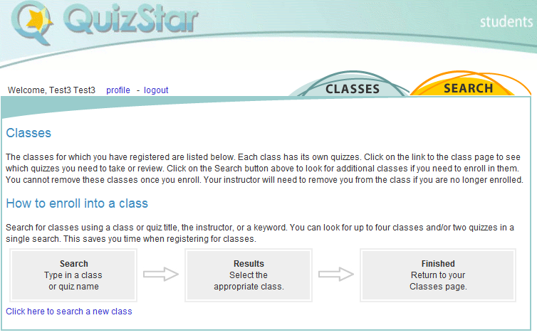
Step 5: In the Class#1 “Class Title: type in “trig transformations”
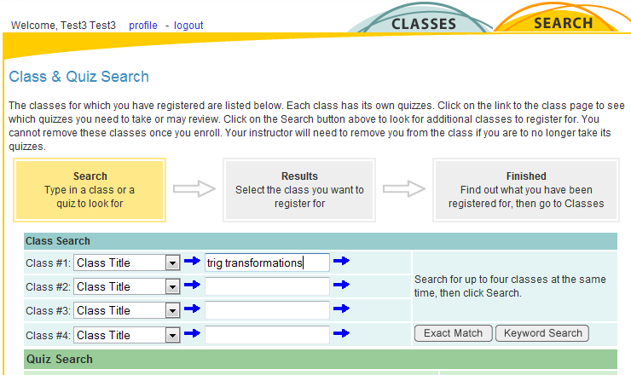

Step 6: Click on the Highlighted Blue “Classes”
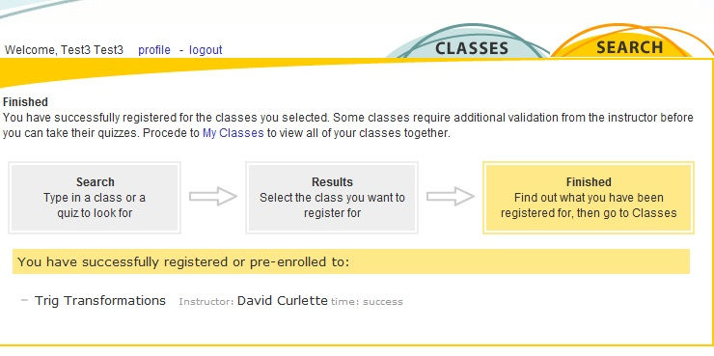

Step 7: Click on the “3 Untaken Quizzes”
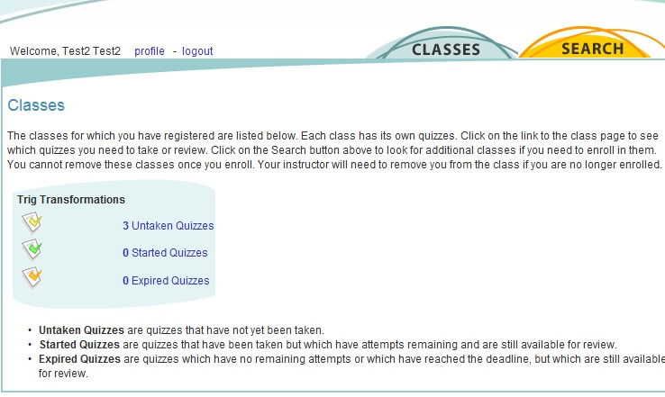

Now click on the quizzes and test to take. Remember you have 10 tries on the quizzes and only 1 try on the test. You have one hour for each quiz and the test.

